PLR Arbitrage
HOW TO MAKE INSANE PROFITS FROM $4 PLR PRODUCTS



PREAMBLE

The general assumption out there is that PLR (Private Label Rights) and PLR products are useless. Nothing can be farther from the truth.

Contrary to the popular opinion that PLR products are over-sold and utterly useless, the statistics still shows that these products sell and every single day more and more of them are created.

The simple fact that you have tons of PLR products cluttering your hard-drive and the simple fact that you will purchase more PLR products before month end is a strong indication that PLR products sell.

So, where did the notion that PLR products are useless come from? Is someone deliberately trying to place a “PLR money screen” on the face of the rest of the Internet population just to deliberately shield the rest of us away from using PLR profitably or what?

Here are the facts:

- PLR products get oversold too fast to make real money. There is no arguing this fact. 48hours after a PLR package is released, so many people have access to it, especially people with huge list, and 4days later, the PLR product starts showing up as FFA (Free For All) content. To make money beyond this time frame takes too much extra work.
- No list, no PLR money. To make any considerable profits from PLR, you need to have previously built a list of subscribers you can quickly sell to or to have a well recognised PLR website people frequent where you can list your products.
- PLR is Cheap. Most sell at a measly $5 compared to the exact same content that Internet markets sell as premium products using the same type of mini-sites at $47 to $97 – To make $200 from a PLR product, you will need to sell 40 copies as compared to just selling 2 copies of a premium $97 PLR product.
- To Make Real Money – You Have To Create It. To make any real money with and from PLR materials, you need to be the creator but even with this, you still stand a chance of being disadvantaged because within 24hours, you will have your PLR products everywhere and you will wonder what hit you, after so many hours of work packaging it. There’s got to be a better way!
- Blah... Blah.. Blah

All these arguments and many more are valid BUT there is a better way out and for the first time ever, you can return to your archives of PLR with a fresh outlook and draw money out of it starting just about NOW.

All you need to do is..

- Find PLR materials (mostly ebooks and reports)
- Buy a group of 10 to 20 cheap PLRs or even download them free
- Do a total makeover and exponentially increase the value of each
- Make 5 to 10 times the original investment in 10 to 14 working days
- Do it all over again

The cool thing about this whole system is the fact that it takes less than 2hours to understand the whole process, you can get started today and 14days from now, you can make your first real PLR arbitrage profits.

HOW TO USE REPORT

This entire report is divided into 3 short sections.

- PART ONE – Describes the whole PLR Arbitrage concept in detail with 3 unique examples to start with immediately.
- PART TWO – Explains and gives you a quick basic skill training to enhance your PLR Arbitrage business. This is like a report within a report – what you primarily call a bonus chapter
- PART THREE – The money chapter. Deals entirely with converting your hard work into sweet cash.

Ready to go?

PART ONE

What Is PLR Arbitrage?
PLR arbitrage is all about buying PLR content for ridiculously low prices and selling at much higher prices with a little make over and there are three unique options described here for you to explore immediately.

OPTION ONE
Buy a bunch of 10 PLR products at average of $8 for each. Invest 2 – 4hours of work on each and 4days later, sell your repackaged work for a total of $500 to $1500.

OPTION TWO
Buy a bunch of PLR products, create a blog empire around these products spanning 50 to 200 websites deep, manage your empire and earn $100 to $200 daily consistently, “almost” on autopilot after a little while.

This method means more work but hey... it also means more persistent revenue.

OPTION THREE
Makeover PLR products into premium packages and sell, then repeat the process.

PLR content as we know it involves buying content where you have very little or absolutely no restrictions whatsoever on your use of the material. For instance, a Private Label Rights content that gives you no restriction means you can easily buy it, stamp your name on it and become an immediate author (which is the original intent of course) or you could buy the PLR and create a video, audio or whatever it is you wish to create about that material.

The problem with PLR is that too many people have too many of it and are making absolutely no money with it. This should not be the case because with a little extra effort, most PLR products lying fallow on your hard drive can make you good money every single day.

The first thing you need to realise about PLRs are:

- They are constantly in demand
- They are valuable
- They should not be lying fallow on your hard-drive

While these statements are true, the conventional methods of making money with PLR materials require a lot of heavy work input that most people just ignore it. For example, to make any considerable income from a PLR product, you will probably have to do the following: (in addition to the task of registering a domain, setting up an autoresponder etc ) Write a new sales copy, create new graphics, setup autoresponders, create new autoresponder follow-ups, re-write the original manuscript, etc

This is a lot of work and while I recommend you do it once in a while when you get a good offer, majority of the methods described here, by-passes all these task for the sake of speed and fast profits.

MARKET RESEARCH

PLR Arbitrage begins here just like most other Internet ventures.

The first thing you want to know is if people want what you are about to create. There is no point wasting time working so very hard on something only to discover nobody wants it. The purpose of all these is to create something someone else wants so you can sell it to them at a higher price. Remember, this is an arbitrage. Buy low, sell high.

So, the first thing is to try and see what people are willing to buy and then focus your arbitrage around this. One important thing to note here is the pitfall of trying to focus on Internet marketing as a niche or what is popularly called the make “money niche”.

Yes – “make money” sells and Internet marketing sells but hey, there are a lot of other niches (markets) waiting to be milked for a lot less effort and this is where you should be looking at.

I have three favourite methods of choosing my niches of focus:
- Keyword research
- Follow the market approach
- Ever green market generalisation

I will start with the last.

EVER GREEN MARKET GENERALISATION

When you think carefully about it, you realise some-things will always sell and then from that point, you can get unique angles within these things that will always sell to make money from. Examples:

- Love & friendship
- Sports
- Cars & car knowledge
- Parenting
- Etc

To make money from PLR arbitrage, I can almost be certain that if I choose parenting and think a little further, things that have to do with Baby names, baby sitting, baby gift, baby learning etc will be a winner.

The only thing I need to do further is to use my keyword research to confirm my suspicion and if its good, I go for it.

I could just as well do something on “How To Fix Your Car without the Mechanic” related and know without any doubt I will have a winner because the car market is alive and there will always be people who will need those quick fixes to get going.

Simple and straight forward.

FOLLOW THE MARKET APPROACH

What are people demanding, what are people buying. Find out, follow the market and target your PLR arbitrage at this. For instance, a visit to online forums or to “exchange” websites like http://flippa.com or the WSO (Warrior Special Offer) section of http://warriorforum.com or http://forums.digitalpoint.com will give you an insight into what people are buying quite easily. You can find similar websites for niches you are interested in and find what sells in these places.

A very good instance that comes to mind is the now popular website, http://flippa.com
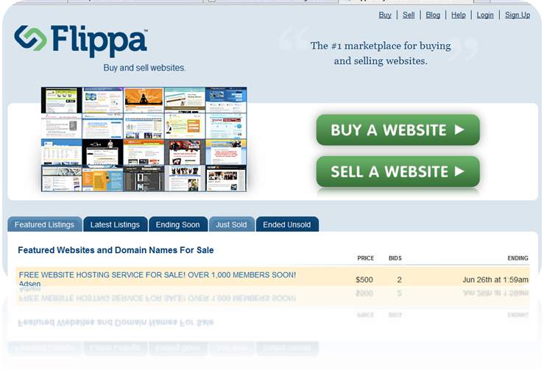
Flippa is a place where people buy and sell website and all you need to do when you get there is simply to click on the Just Sold link on the home page to get a glimpse of what people are buying and for how much; and a lot of ideas instantly jump at you from diverse and varied niches.

See http://flippa.com/buy/listings/sold

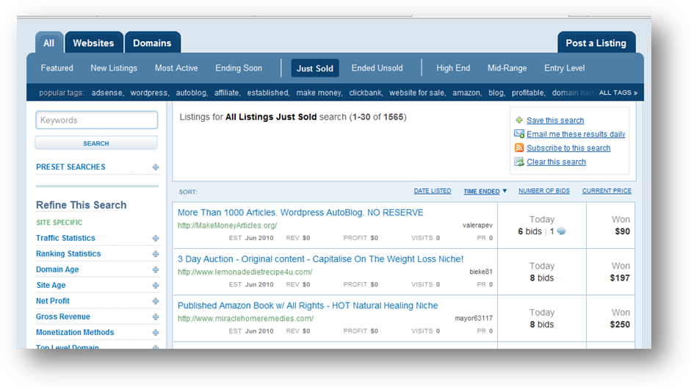
Check the area marked with a bright red ring to see what sites were recently sold and for how much and you get exciting ideas of markets to target as you drill down.

KEYWORD RESEARCH

With keyword research, your primary objective is to know what people are searching for and then target it. Thankfully there are a host of tools to help with this ranging from free to premium.

Websites like http://wordtracker.com helps you get started. The good thing about keyword research is the fact that you are able to discover and unearth niches and keywords you will probably never have thought about using the first other two methods. Take “parenting” which is a broad topic as an example.

Using the Google keyword tool
https://adwords.google.com/select/KeywordToolExternal to run a search on the work “parenting” here’s what I came up with.

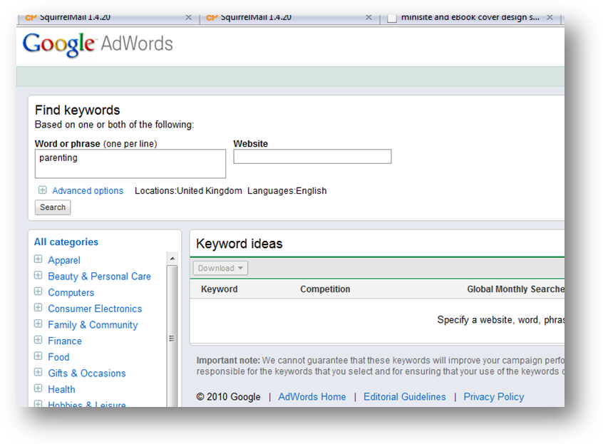

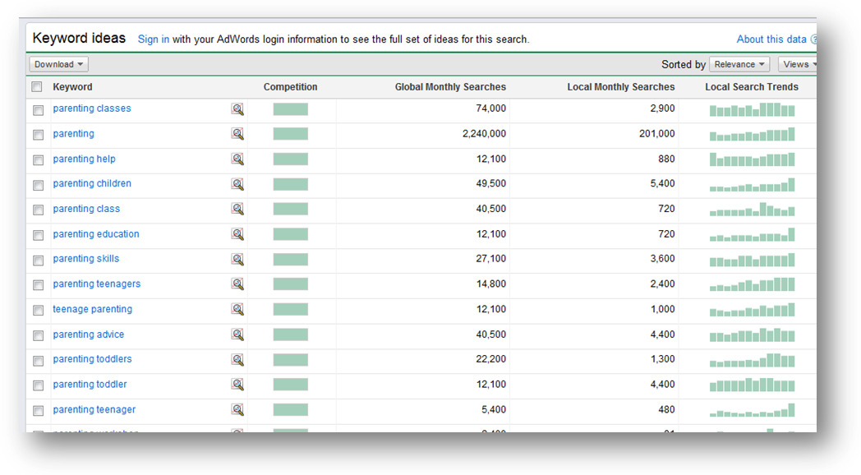
Above are the results which shows that the word parenting gets about 2million+ searches per month.. and to get even more, I can just click on the Previous Interface button and I redo the search to get keyword ideas.

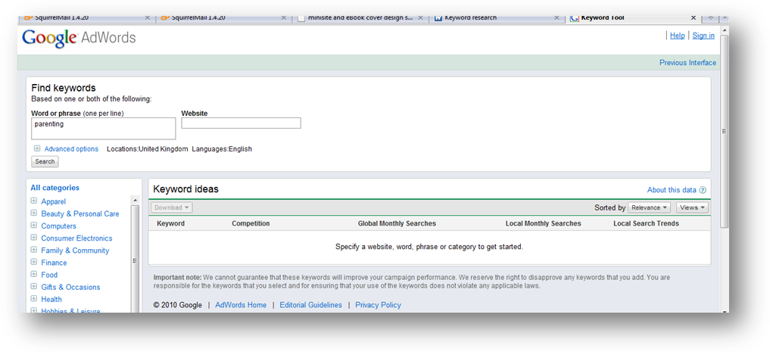

Here is how it looks and the result I get for the keyword pareting.

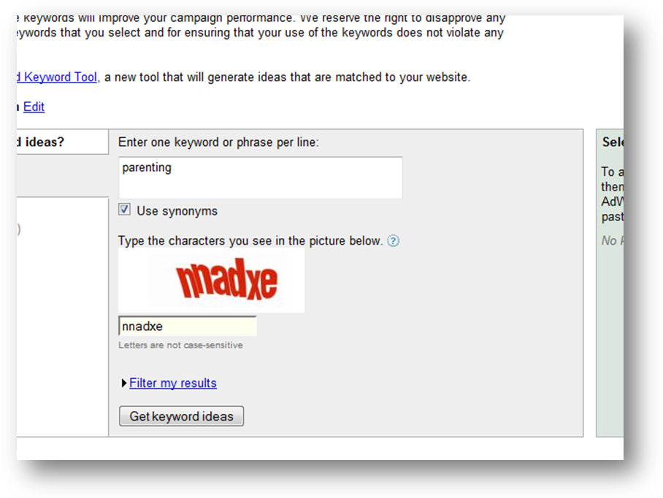
The result I get gives me even more options and statistics to work with. Keyword ideas I did not initially think of:

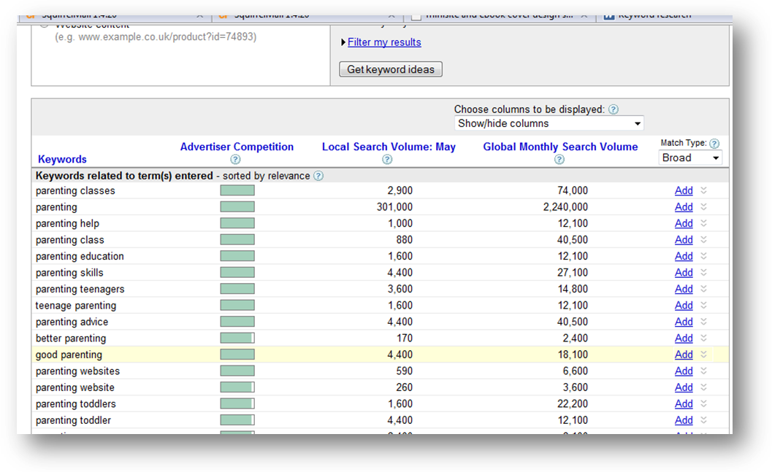

BUYING YOUR PLR

Once you have decided on a niche to target for your PLR arbitrage, it is time to take the next step which is to buy your PLR and there are a lot of places to do this. For instance http://nicheaudioclub.com, http://easyplr.com

A good idea for buying dirt cheap PLR content is to see the WSO section of WarriorForum and lookout for large PLR offers. It is not uncommon to find PLR packages containing 20 to 40 well written ebooks at under $50 which comes down to about $2.5 per ebook and you can get articles for far less.

Make certain a great percentage of the materials in the package you are buying are things you’d like to work on as soon as possible. No point stocking your PC with loads of PLR materials you don’t intend to use.

PLR ARBITRAGE METHOD ONE

Get 10 PLR content materials, buy a good domain name for each of these PLR materials which totals 10 domains. Quickly install Wordpress blogs on the domains (this is covered in section two) and if you have the blog to make it look good which increases your flipping power.

Extract from your PLR content 5 to 10 articles and post it on your blog to publish over a 7 to 14 day period. Post a couple of these on article sites as well and then follow the money methods in part 3 of this report.

With any luck, you should make between $500 to $1500 possible within the next 14days from this effort simply by selling off all the 10 websites.

PLR ARBITRAGE METHOD TWO

Follow all the steps in method one but this time around you won’t be selling your blog sites, you will be building an empire of blog sites. You target is to have 50 to 100 blogs within your blog empire and the maths is quite straight forward.

Have 100 websites each earning $2 to $40 daily and you will end up with $200 to $4000 per day. When you think about it, you realise it does not take much effort to achieve this figure. Just convert all your idle browsing time into blog empire building, take your seemingly useless PLR products and build wordpress blogs around them.

Make $2 a day from Google adsense, affiliate marketing, Pay per post and advert selling on your blogs and hit $200 per day in a few months.

Agreed, this method takes some time and effort to build but it is one of the most sticky income earners around plus, when you have a blog empire, you can always revert back to method one and make a killing whenever you are cash strapped.

PLR ARBITRAGE METHOD THREE

This is the easiest and fastest to do and it is all about making your own PLR package unique.

Buy a bunch of PLR packages and put them together in a new way. You could even buy materials on the same topic and combine them to form a fresh PLR material entirely. Buy a domain name for your PLR, create a new sales copy and ebook covers. You can do this easily enough using services like http://www.coverscorp.com/ and many other services online.

Once done, set a price for your brand new ☺ package and market it using a host of channels.

PART TWO

FAST TRACK BLOGGING TRAINING

Using blogs to completely turn around the fortunes of your PLR products is very easy and you can complete 5 projects per day working in a focused way from 8am to 4pm (regular work hours) but first you need to understand how to work with blogs and here is a fast training.

Step One – Register a Domain Name
You can easily do this at http://007names.com or http://dynadot.com

Step Two – Get Webhosting
I strongly recommend HostGator. They have one of the best webhosting support I have seen in the last 8years of online presence with 24/7 online chat support. So no matter the question, someone is always awake to give instant assistance.

If you ever get stuck with setting things up, the HostGator support will be there to help you out quickly.

Step Three – Setup Your Blog

Login to the Cpanel (control panel) of your website by going to http://www.mysite.com/cpanel. The username and the password you will use to access this part of your web will be supplied to you by your web hosting company.

Login to your cpanel and locate an icon labelled “FANTASTICO” then click on it.

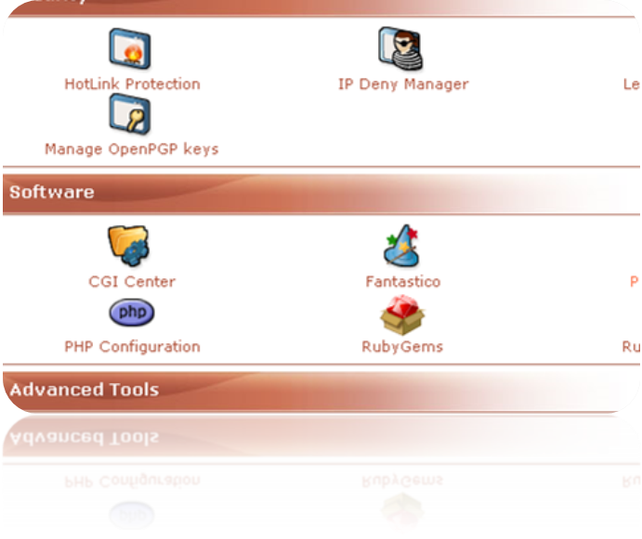
NOTE:
Your site outlook may be different from the ones in the screens shown here. Don’t worry about it, just locate the labels described.

On the next page you will see a lot of pre-installed scripts that you can install on your site to do a variety of things. The one we’re concerned about is the script for installation of blog, and the blog we’re going to install is wordpress blog. So click on the wordpress link as shown by the red arrow below.

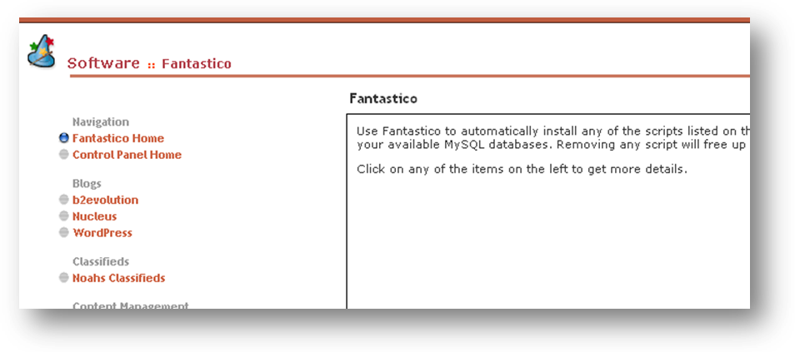

On the page that loads up next, you will see a message that informs you of disk space available, the amount of disk space that the installation will take up and whether you have installed one blog before now. If you have enough space to install your blog the next thing you should do is to click on the link “New Installation” and you’re on your way to installing your blog.

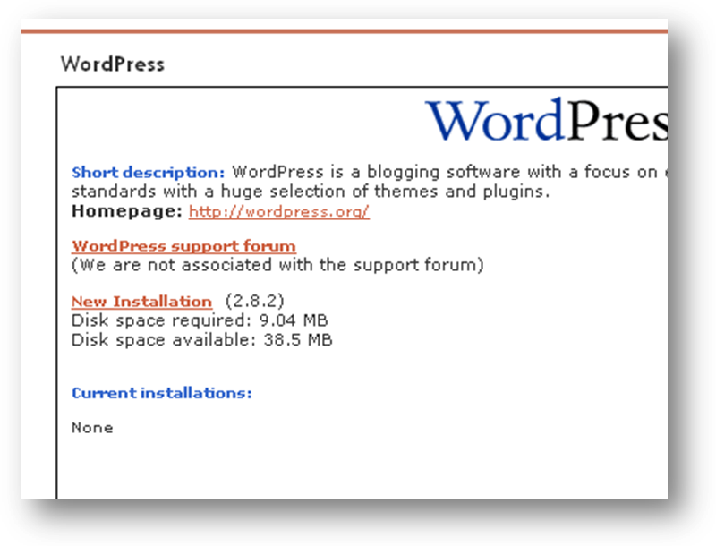

Click new installation and complete a few information like:

example.com

INSTALLATION LOCATION:
this is to specify the directory you want your blog to be installed into and this can either be in the root folder or a different folder.

INSTALL ON DOMAIN:
This will automatically show your domain name as mywebsite.com. If you have more than one domain on your hosting account use the drop down arrow to select the domain you want the blog to install into.

INSTALL IN DIRECTORY:
If you don’t want your blog to be your main page, i.e. you’ve already uploaded your website and you still want to install a blog on the same domain, then typr the name of your blod in this column. For example you can just type blog, which means the blog will be intall into the directory called blog. The the url to your blog will now look like this http://www.mywebsite.com/blog

ADMIN ACCESS DATA:
This is where you will specify your username and password to log in to your blog as the administrator. So fill in your username and password. I hope this is self explanatory.

BASE CONFIGURATION:
Here you have the liberty to configure your blog to suite the theme of your blog.
Admin Nickname: This is the name that the visitor to your blog will see and known as the administratoe, whatever name you choose here will brand you as the administrator of the blog.

ADMIN E-MAIL:
This is the email address that you will be using to communicate with your visitor so input a functional email in this column.

SITE NAME:
This is where the branding starts from. Give a name that best suite your theme and that your visitor will understand. Let it be short and easy to remember.

DESCRIPTION:
You now have the liberty to give a few description of what your blog is all about in about one or two sentences. Use the main keyword for your site so that you can be found by a search engine.

After all these click on “Install Wordpress”

INSTALLATION CONTINUE
After clicking Install Wordpress, a new page pops up telling you the process that will be done. If you’re satisfied with the steps to be taken then click on the button “Finish Installation”.

INSTALLATION COMPLETED:

Seeing this page means that you have successfully installed your blog. One more thing is to enter your email address in the box provided so that the details of your installation will be sent to you. Make sure that you do this; it may save you a lot of headache in the future.

VIEW YOUR BLOG.

Type your url into the address bar of your browser and hit enter on your keyboard. Your blog will show up as below.

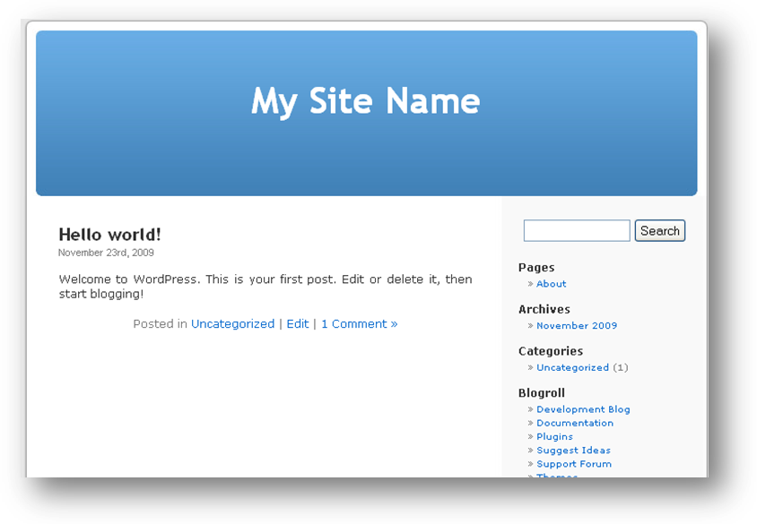

Congratulations! Your blog is up and running.

LOGIN TO YOUR ACCOUNT:

To login into your account where you administer your blog, type the url of the login page as http://www.mywebsite.com/wp-admin/, on the login page, input your username and password so as to log in as the administrator.

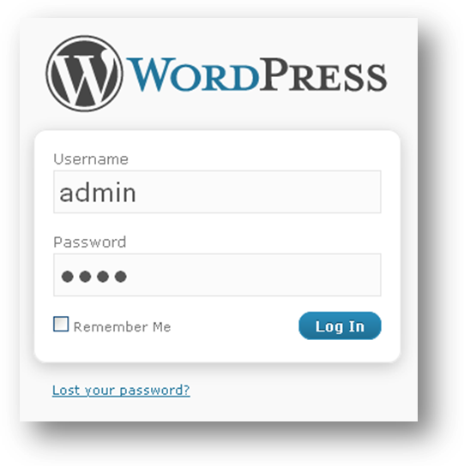

You are next presented with your Dashboard, this is where you carry out changes to your blog as you wish and you can start immediately by doing a few customization and add your first content to your blog site.

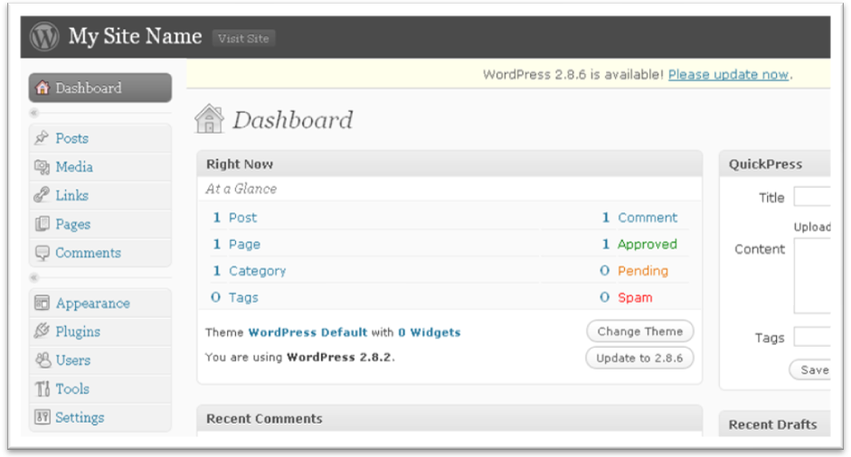

ADD A NEW POST:

See the red rectangle, if yours is not exactly like that click on the small inverted triangle as pointed by the black arrow and the sub-menu of post will flip out. Now click on the link “Add New” and a page will come up where you will type in your post or copy and paste your already typed post into the box provided. Also type the title of you post in the title column.

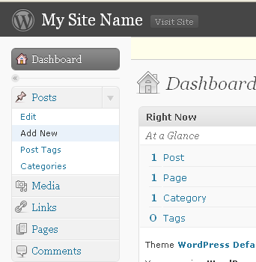

When done, click “Publish” You can edit or delete this later, but then there are a few more basic things you should learn.

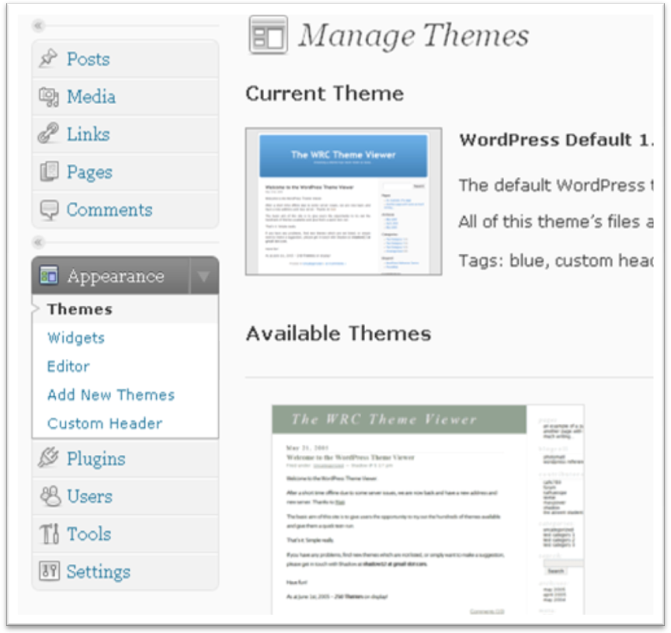
CHANGE BLOG THEME

To change the theme of your blog, click on the drop down arrow on the link “Appearance” and click on “Themes”. The next page shows you the number of themes already pre-installed on your blog and you can change to any theme you like as often as you require.

To change the theme, click on the theme you want to change to and you will see the changes immediately. Just go and refresh your blog and you will see that the change to the theme has taken place.

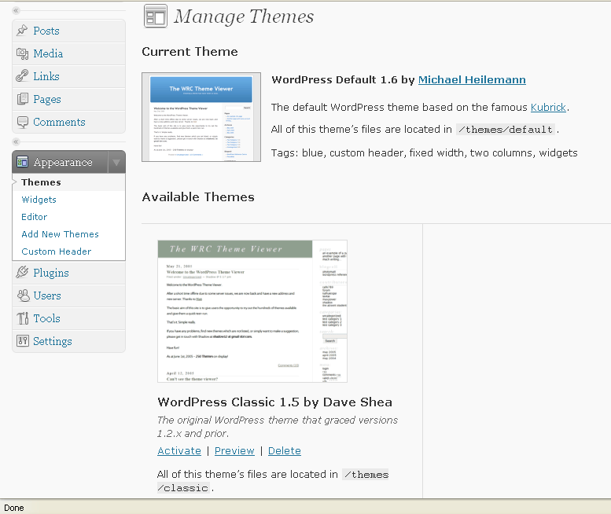

This is the new theme.

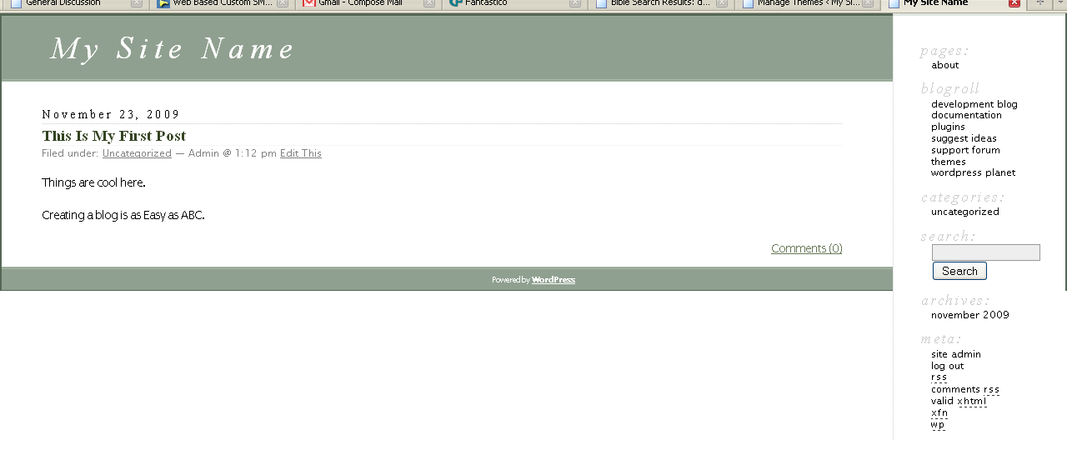

INSTALLING MORE THEMES

You can install more themes on your blog to radically alter appearance. To do this click on the link “Add More Themes”. On the page that shows up pick and description of the type of theme that you want to install by clicking the radio button against the themes you like.

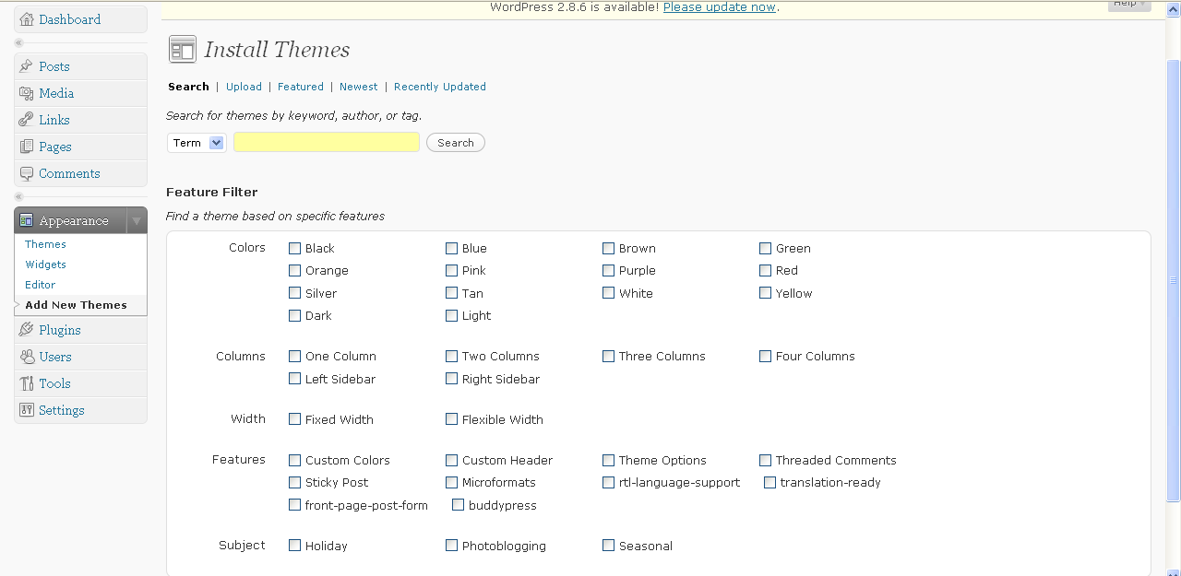

As you choose the type that you want the themes in that category shows up and you can now pick the theme that appeals to your and the one that suites the theme of your blog.

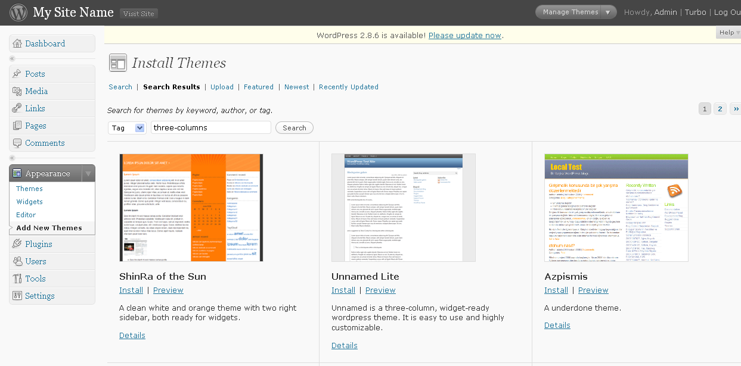

For the purpose of this tutorial I will use the theme in the red rectangle above.

Click on the theme and it will show you a preview, if it pleases you, click on the link “Install Theme Name’” on the upper right hand corner of the previewed theme as shown below with the arrow.
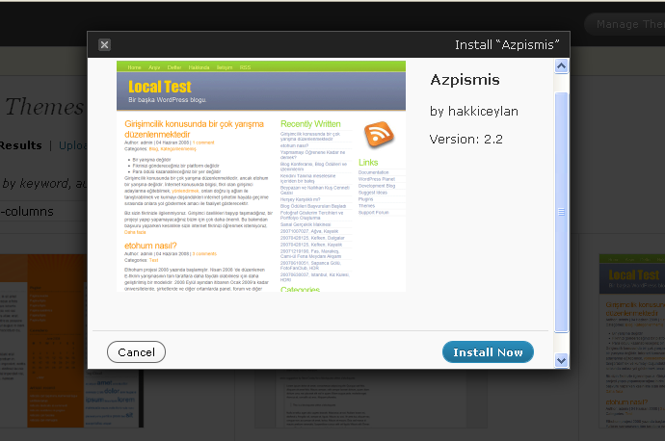

After the installation, the theme will show up in your Available Theme area, ready for you to activate.

To activate the new theme, simply click on the theme and it will be activated.

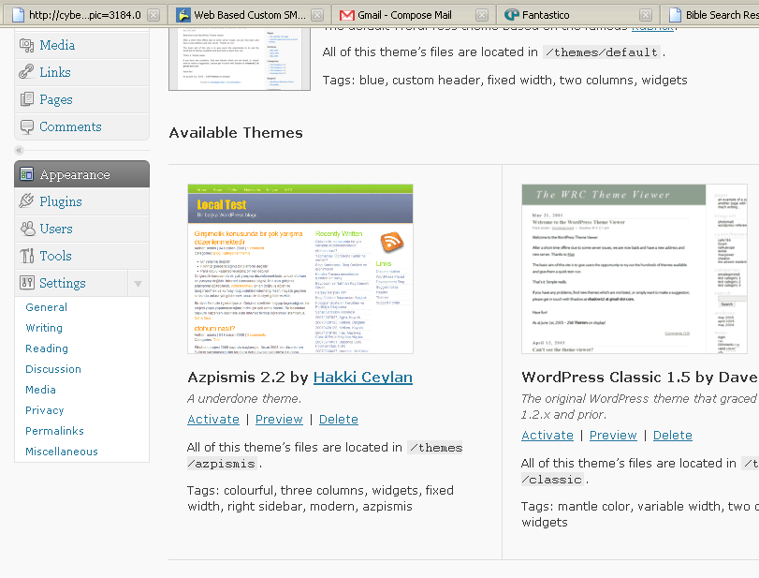

After activation, refresh your blog and you will see something like the picture below.

You’ve successfully installed and changed the theme of your blog.

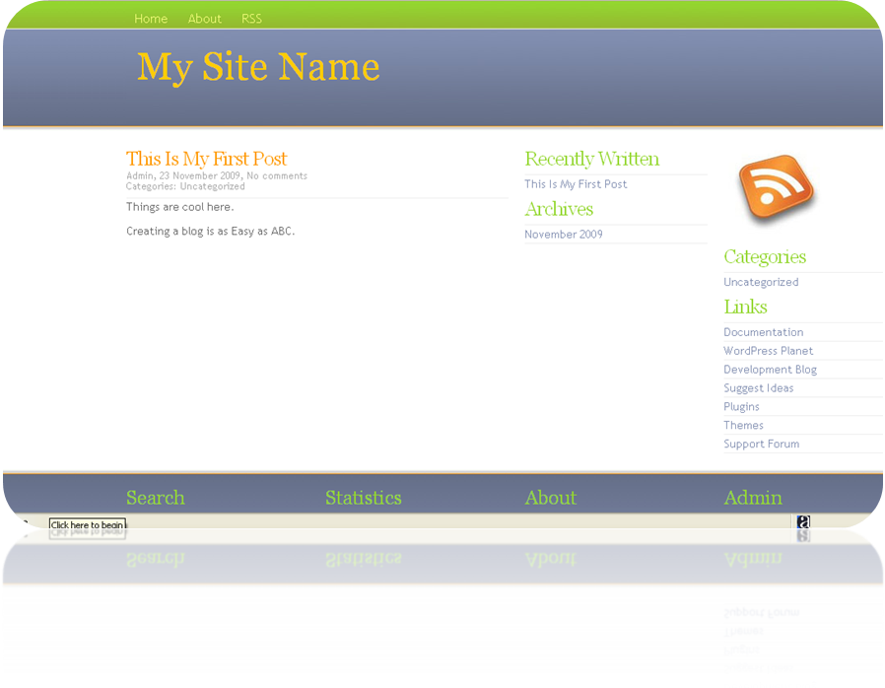
CONFIGURING THE PERMALINK

The next configuration you need to do now is configuring the permalink. The permalink is the url ot your post. The pre-set permalink looks like something below.

http://mywebsite.com/?p=3

If you click on any of the post on the blog the url of that particular blog will look like the one above. This is the preset one.

Your permalink is very important because it allows the search engine to pick up your blog post if anyone does a search by search engine for a keyword that your post is being optimized for. But if you leave the link as default the search engine will not be able to pick up your post and by this you will be leaving your prospect to go to the blog of your competitors.

So to configure the permalink, click the drop down arrow on the Setting menu and then click on the sub menu Permalinks. You should know where the link is by now.

Click on the sub-menu permalink and edit the configuration in the red rectangle below.

Check the radio button and type “%postname%” (without the quotes) into the box and click the button Save Settings.
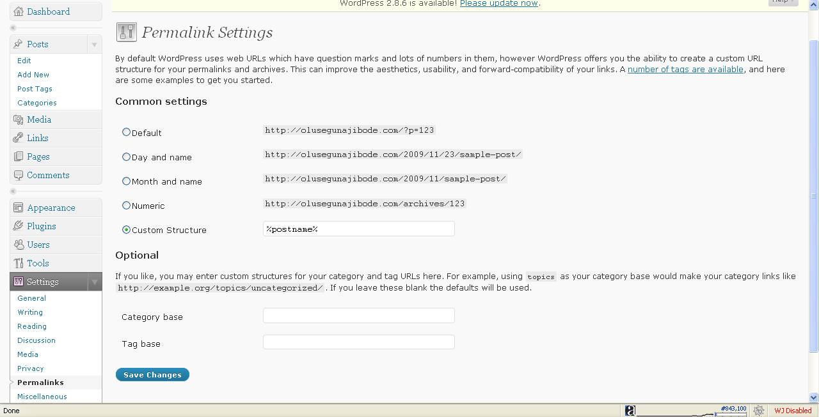

Now refresh your blog and click on any post on your site and check the url on the address bar as soon as the page loads.

You will see the url of the post like the one here;

http://mywebsite.com/this-is-my-first-post

Assuming that the title of your post is “This Is My First Post”

Congratulations, you now know how to quickly turn your PLR packages into blog sites and now you are ready to turn on the money tap.

NOTE:
Find more resources about blogs and blogging to further understand wordpress blogs and how they work

PART THREE

MAKE YOUR ARBITRAGE EFFORTS PAY

OKAY…

Here’s the part you signed up for and this is the section where you work at making all your effort pay. Right?

It is not just enough to work on your PLR arbitrage unless you are going to make money from it and that’s what this section is about. It is all about making money from each of the 3 methods outlined in part one.

The first method is all about turning your PLRs into blog sites, with high quality content (which of course is lifted from your PLR materials), throwing in a unique theme. See websites like http://www.freewpthemes.net/, http://www.smashingmagazine.com/2008/01/08/100-excellent-free-high-quality-wordpress-themes/, http://wordpressthemesbase.com/, http://www.themes2wp.com/ etc for free themes to use.

Install these new themes, and then go to places like http://warriorforum.com, http://forums.digitalpoint.com, http://flippa.com to sell your blog. If your blogs are high quality blogs in great niches, you can easily sell for between $200 to $1,500 depending on the blog, its content, age etc

However, you should easily average $100 to $150 per blog and since you will be working with easy to obtain PLR content and blogs with unique content, you can easily sell bundled blog offers on these sites to make money faster.

The goal is to quickly turn your PLR into high cash return, then go back to repeat the process over and over again.

To quickly sell your blogs in the marketplace, make sure you write good description for your offers. Bear in mind that on some sites, you will need to specify the price you are offering while in some others, a bidding process is what takes place like on http://flippa.com (although you still get to reserve a price).

So your description should be good ones.

If you are going the way of method two and you plan to build a personal blog empire spanning hundreds of blogs which you then optimise to earn you $2 to $40 per blog per day, you need to consider the following:

- Your blog advertising strategy
- Your blog monitization strategy
- Your blog content strategy

Your blog content and advertising can be inter-twined to make one unique whole for instance by using the Bum Marketing method: http://bummarketing.com where you use articles to drag traffic to your website.

I particularly love this method because you can set it up and leave it to focus on other blogs and the site will run itself for months to come. You only need to come back once in a while to add new materials (or you can just schedule content for like 3months while you focus on building more blogs).

Now, as you work hard on these blogs, you should think seriously of ways to make money from it and here are a few of the ways you can easily get started with.

- Google Adsense – It is rather easy to make $2 per day from each of 100 blogs under this method with your bum marketing strategy. Quite easy – it only needs mastering the process
- Affiliate Marketing – while targeting $2 per day from Google adsense, a good idea is to sell affiliate products on your blog using banner advertising and aim at possible one such sale per day at an average commission of $17 per sale. (Not all your sites will sell 1 affiliate product per day but hey.. when you use the number approach, this becomes really really workabale)
- Sell Your Own Products – offer your our low cost items on your website (low cost PLR) for instance of like $7 to $10 per sale across all your wordpress blog sites. 20 copies sold cumulatively each day will give you an extra $140 to $200, 100% yours.
- Participate in Pay Per Post programmes e.g. http://socialsparks.com, http://payperpost.com, http://reviewme.com, http://sponsoredreviews.com etc You will easily earn extra revenue from those quite easily.
- Sell links on your blog e.g. http://textlinkads.com
- Sell banner ads on all your blogs e.g. Wordpress banner ads of 125 by 125

Each of all these can be easily achieved with the least of efforts by using Plugins. There is just about nothing you wish to achieve whose plugin is not already in existence and here are a few plugins you should have to get you started for monitization immediately.

Max Banner Ads
Easily rotate banners and ads in almost anywhere in your wordpress blog without editing the theme.

Download This FREE Plugin - Max Banner Ads

SEO Pressor
Complete SEO solution for your Wordpress blog
http://imezurl.com/seopressor

Google Analytics for WordPress
This plugin makes it simple to add Google Analytics with extra search engines and automatic clickout and download tracking to your WordPress blog.

http://yoast.com/wordpress/google‐analytics/

Easy Privacy Policy Plug‐In
Unfortunately the author’s site is down at the moment, but just type in ‘privacy policy’ in the search box at Wordpress.org and choose the one by Kevin Sparrow:

http://wordpress.org/extend/plugins

http://www.oiopublisher.com/ has a fantastic package for maximizing revenue too.

Do a search for important wordpress pluging and you will get a ton of them to work with.

TRIM OUT YOUR BLOG EMPIRE

One of the most important things you should do with your blog empire is to trim them down to only the ones producing the very best results and this will become evident over time. Those not performing at the level you expect should be sold off following method one, while you retain on the super blogs to swell your blog empire and make you good money.

Finally, if you are looking to create a unique angle to existing PLR content and make quick sells, you will need to take time out to repackage the content, make it look unique and too good an offer to resist, write a sales pitch for it, have samples materials and sample screen shots ready, set a price and do a Warrior Special Offer on http://warriorforum.com or sell on http://forums.digitalpoint.com

A smart move you can make for this model is to look at these websites, find someone selling something similar to what you intend to sell and looks to be successful and model after it.

